SYDNEY WESTERN CITY PLANNING PANEL
Section 4.15 Assessment Report

Panel Reference | PPSSWC-608
DA Number | DA0013/25
LGA | Hawkesbury City Council
Proposed Development | Animal boarding training establishment - demolition of existing structures, remediation of the land, construction of two stable buildings, outbuilding, associated car parking, landscaping works and the reconstruction of Rickaby Street.
Street Address | 61 Rickaby Street, Clarendon NSW 2756  Lot 128 DP 752061
Applicant/Owner | Applicant: Racing NSW  Owners: Racing NSW
Date of DA lodgement | 25 January 2025
Total number of Submissions | Two (2) submissions
Recommendation | Approval
Regional Development Criteria | Council related development over $5 million
List of all relevant s4.15(1)(a) matters | - Environmental Planning and Assessment Act 1979  - Environmental Planning and Assessment Regulations 2021  - State Environmental Planning Policy (Biodiversity & Conservation) 2021  - State Environmental Planning Policy (Resilience & Hazards) 2021  - State Environmental Planning Policy (Transport & Infrastructure) 2021  - Hawkesbury Local Environmental Plan 2012 (LEP 2012)  - Hawkesbury Development Control Plan 2002 and 2023 (HDCP 2002 and 2023)  - Hawkesbury City Council Flood Policy 2020
List all documents submitted with this report for the Panel’s consideration | - Accessibility Assessment Report  - Arboricultural Impact Assessment  - Architectural Plans  - Building Code of Australia Assessment Report  - Bushfire Assessment Report  - Clause 4.6 Variation Request  - Cost Summary Report  - Delegation of Authority (Crown Lands Owners Consent)  - Detailed Site Investigation Report  - Ecological Assessment Report  - Emissions Materials Form  - Fire Emergency Plan  - Fire Services Plans  - Flood Assessment Report  - Flood Emergency Response Plan  - Hydraulic Services Plan  - Land Zoning Plan  - Landscape Plans  - Noise Impact Assessment Report  - Odour Impact Assessment Report  - Owners Consent  - Plan of Management  - Preliminary Geotechnical Investigation  - Preliminary Site Investigation Report  - Remediation Action Plan  - Site Plan  - Soil Management Plan  - Statement of Environmental Effects  - Stormwater Management Report  - Stormwater Plans  - Traffic Impact Assessment  - Waste Management Plan  - Wastewater Management Plan
Clause 4.6 requests | Yes – Clause 4.3 Height of Buildings
Summary of key submissions | Two submissions were received – one in support of the proposal and one objecting to the proposal. The submission in support is primarily related to the economic benefits of the proposed development. The objection raises concerns with hours of operation, driveway location, location of walking machines and operational noise.
Report prepared by | Hugh Halliwell – Consultant Planner
Report date | 4 November 2025
Summary of s4.15 matters  Have all recommendations in relation to relevant s4.15 matters been summarised in the Executive Summary of the assessment report? |  | Yes
Legislative clauses requiring consent authority satisfaction  Have relevant clauses in all applicable environmental planning instruments where the consent authority must be satisfied about a particular matter been listed, and relevant recommendations summarized, in the Executive Summary of the assessment report?  e.g. Clause 7 of SEPP 55 - Remediation of Land, Clause 4.6(4) of the relevant LEP |  | Yes
Clause 4.6 Exceptions to development standards  If a written request for a contravention to a development standard (clause 4.6 of the LEP) has been received, has it been attached to the assessment report? |  | Yes
Special Infrastructure Contributions  Does the DA require Special Infrastructure Contributions conditions (S7.24)?  Note: Certain DAs in the Western Sydney Growth Areas Special Contributions Area may require specific Special Infrastructure Contributions (SIC) conditions |  | Not applicable
Conditions  Have draft conditions been provided to the applicant for comment?  Note: in order to reduce delays in determinations, the Panel prefer that draft conditions, notwithstanding Council’s recommendation, be provided to the applicant to enable any comments to be considered as part of the assessment report |  | Yes

1. Executive Summary

Racing NSW have lodged a development application for the redevelopment of 61 Rickaby Street, Clarendon (the subject site) for an animal boarding and training establishment and associated works including the demolition of existing structures, remediation of the land, construction of two stable buildings, a waste and store shed, four (4) horse walkers, sand rolls, wash bays and tie-up stalls, truck and car parking, a pump room and rainwater tanks, landscaping works and the reconstruction of Rickaby Street.

The proposal seeks to redevelop the subject site for the purposes of an animal boarding and training establishment for horses. The development will operate 24 hours a day, 7 days a week to provide stabling facilities for horses and associated infrastructure. The development will support trackwork 7 days a week between 5am and 10.30am at Hawkesbury Race Club.

The subject site is one of several rectangular allotments fronting Rickaby Street with an area of approximately 2.026 hectares and adjoins Hawkesbury Race Club to the rear. The site is generally flat and is identified as being affected by flooding, bushfire and mapped as potentially containing acid sulfate soils. There is some native remnant vegetation on the site, however there are no significant stands of vegetation that are considered to be a significant contribution to biodiversity values of the Hawkesbury region and surrounds.

The application has been lodged as a development application under Part 4 of the Environmental Planning and Assessment Act 1979, and is subject to the requirements of Hawkesbury Local Environmental Plan 2012 (Hawkesbury LEP). The proposal is not integrated development and does not require general terms of approval or concurrence from any agencies.

The subject site has a maximum permissible building height of 10m in accordance with the Height of Buildings Map in clause 4.3 of Hawkesbury LEP. The proposed barns/horse stables have a building height of 11.5m and therefore exceed the maximum permissible height of buildings for the subject site. The applicant has submitted a request to vary the maximum building height development standard under clause 4.3 utilising the provisions of clause 4.6 of Hawkesbury LEP.

In accordance with Hawkesbury Community Participation Plan, the development application was notified for a period of 14 days from the 10 February to 24 February 2025. At the completion of the notification period and at the time of writing, two (2) submissions have been received by Council with respect to the proposed development. One submission was in support of the proposal, primarily on the grounds of economic benefits, and the other submission was an objection raising concerns with hours of operation, driveway location, location of walking machines and operational noise.

The site is zoned RU4 Primary Production Small Lots under the Hawkesbury Local Environmental Plan 2012. The proposed development is defined as “Animal boarding or training establishment” which is permissible with consent in the zone. The proposal is also subject to the requirements of Hawkesbury Development Control Plan 2023 (Hawkesbury DCP).

The estimated development cost (excluding GST) for the proposal is $22,348,432 and is categorised as ‘regionally significant development’ in accordance with Clause 2.19(1) and Schedule 6, Clause 3(d) of State Environmental Planning Policy (Planning Systems) 2021 (Planning Systems SEPP) as the proposed development is Council related development with an Estimated Development Cost of over $5 million. Therefore, the consent authority for the proposed development is the Sydney Western City Planning Panel (SWCPP).

The DA has been referred to the Regional Planning Panel as it involves the proposed transfer of Rickaby Street from the Department of Crown Lands to Council. The transfer is required to facilitate the works proposed to Rickaby Street, which are intended to be undertaken by Council. Clause 3(d) of Schedule 6 of the Planning Systems SEPP states:

(d) the council is a party to any agreement or arrangement relating to the development (other than any agreement or arrangement entered into under the Act or for the purposes of the payment of contributions by a person other than the council).

A deferred commencement condition is recommended requiring that the transfer of Rickaby Street from Crown Lands to Council be completed prior to the consent becoming operative.

The subject Development Application has been assessed having regard to the applicable planning controls and it is considered that the proposed development is satisfactory. In this respect, it is recommended that the subject Development Application be approved, subject to conditions.

2. Background

On 11 September 2024, the development application was submitted via the NSW Planning Portal on 11 September 2024 (PAN-469613).

On 20 September 2024, Council issued a request for information to the applicant relating to owners consent, Crown consent, details of Rickaby Street upgrade, contamination, on site stormwater detention and waste management.

On 17 October 2024, a meeting was held between Council, the Applicant and their consultants. At that meeting, various items pertaining to Council request for information from 20 September 2024.

On 25 January 2025, the development application was formally lodged into Council’s system.

On 29 January 2025, the development application was internally referred to Council’s Engineer, Parks Officer, Environment and Regulatory services, Building Surveyor and Sewer Management Facility Officer.

Between 10 February and 24 February 2025, the development application was publicly notified to nearby and adjoining properties with two submissions received in response. Details of the submissions are discussed further in section 12 of this report.

3. Site Description & Conditions

The subject site is known as 61 Rickaby Street, Clarendon and is legally referred to as Lot 128 in Deposited Plan 752061 with a total area of 2.026 hectares.

The subject site is regular in shape and contains a two (2) dwelling houses, three (3) stable barns, six (6) sheds and two (2) awnings. The subject site contains a mix of planted native and exotic vegetation scattered vegetation across the site. The land is generally flat with a level of 15.05m AHD measured at the northeastern corner and 13.77m AHD in the northwestern corner of the site where it adjoins Rickaby Street. Stormwater drainage from the site falls to the northwestern corner of the site and a mid-way low point on the southern boundary, illustrating an irregular and undefined drainage pattern on the site. Runoff from buildings is collected from downpipes with no known location of disposal.

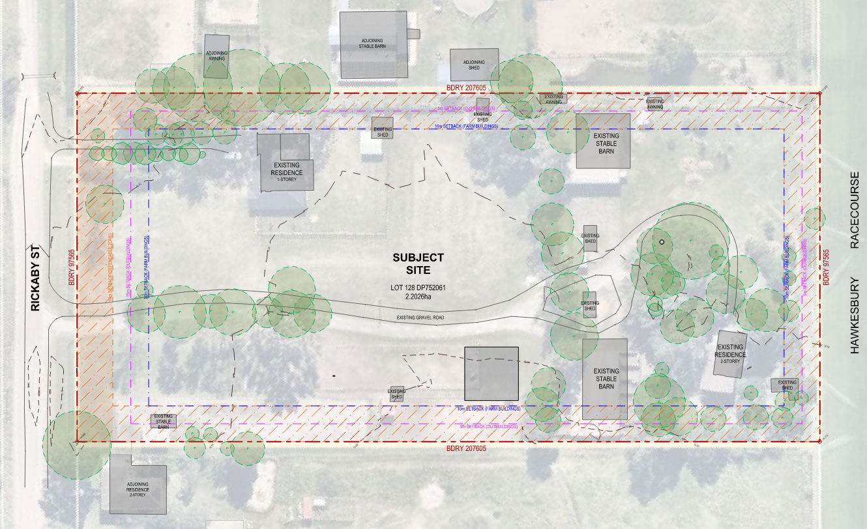
Figure 1. Existing Site Plan. Source: EJE Architects

The subject site is mapped as being bushfire prone land within the vegetation buffer zone on the Bushfire Prone Land Map; is mapped as Class 5 Acid Sulfate Soils; is affected by flooding with a potential depth of 2-4m during the 1% Annual Exceedance Probability (AEP) flood even, does not contain but is adjacent land identified on the Terrestrial Biodiversity Map, and adjoins land owned/managed by Crown Lands NSW, including Rickaby Street which is a Crown Road. The relevant mapping for each is provided below.
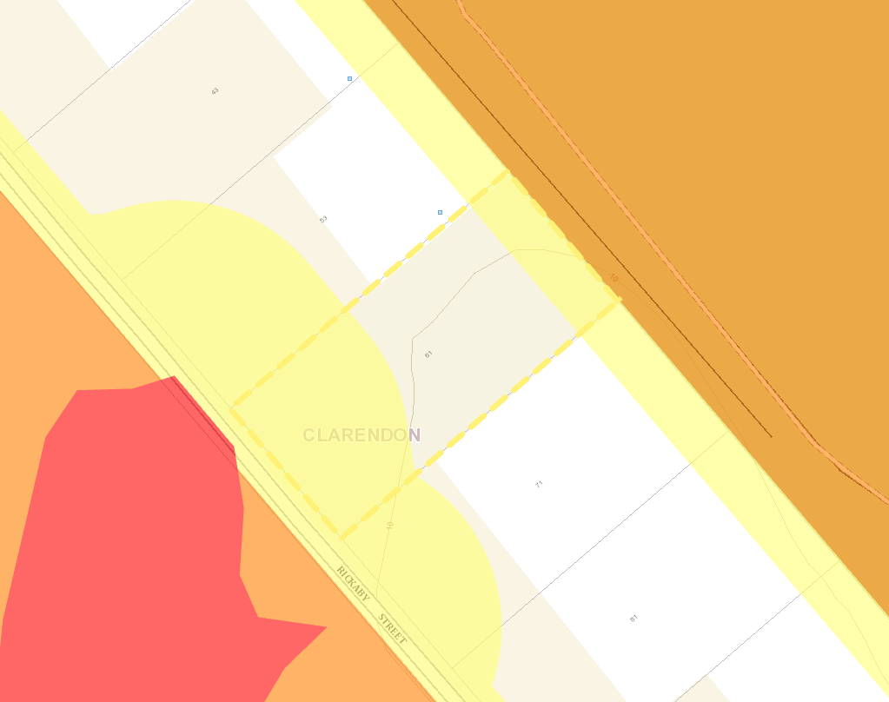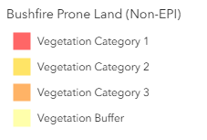
Figure 2. Bush Fire Prone Land Map. Source: NSW Planning Portal

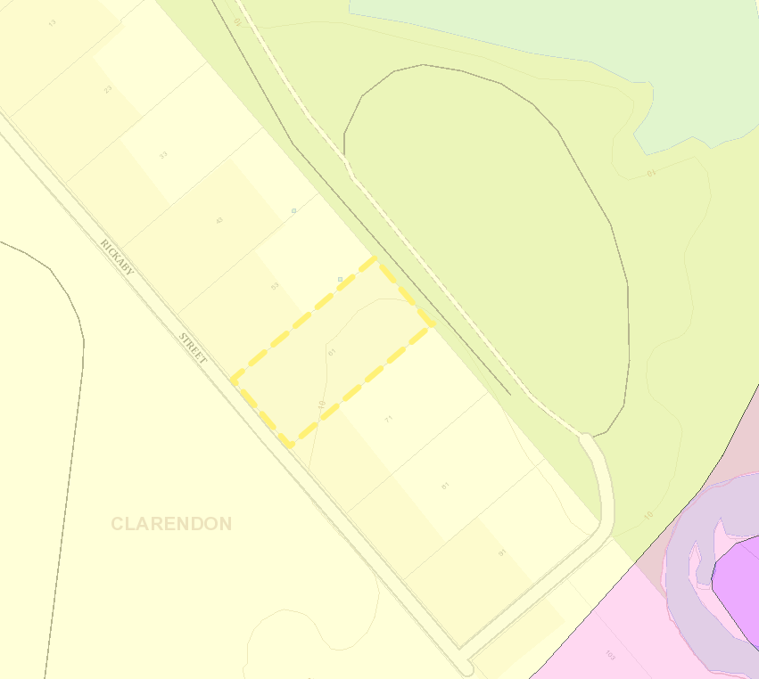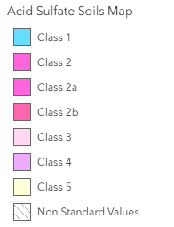
Figure 3. Acid Sulfate Soils Map. Source: Hawkesbury LEP via NSW Planning Portal

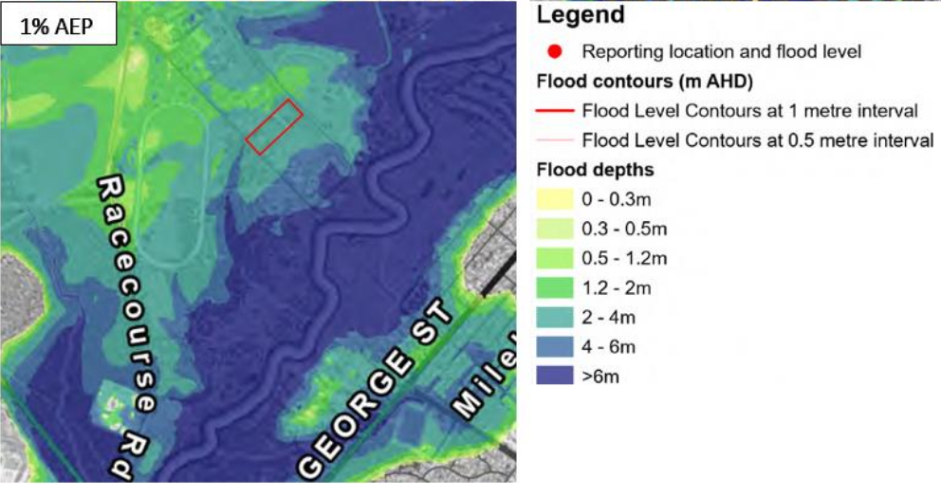
Figure 4. 1% AEP Flood Map. Source: GRC Hydro

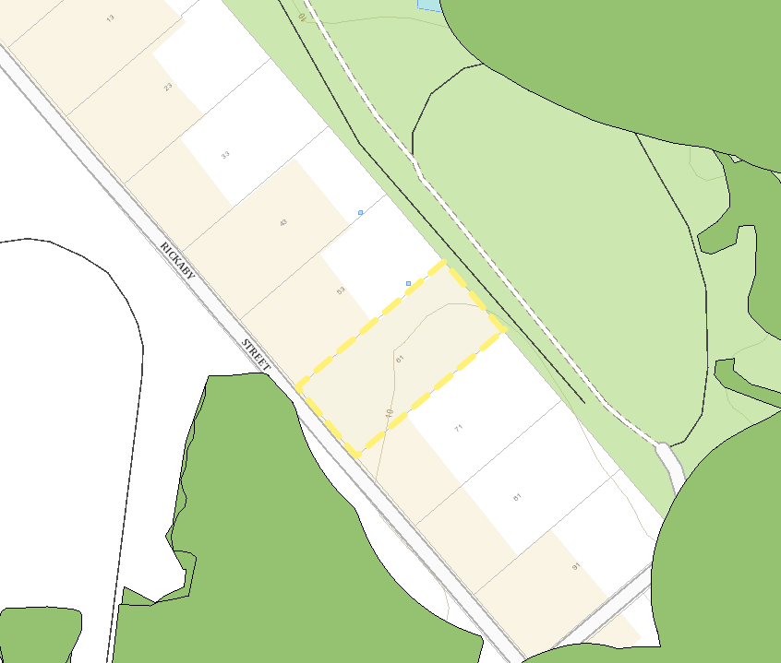
Figure 5. Terrestrial Biodiversity Map. Source: Hawkesbury LEP via NSW Planning Portal

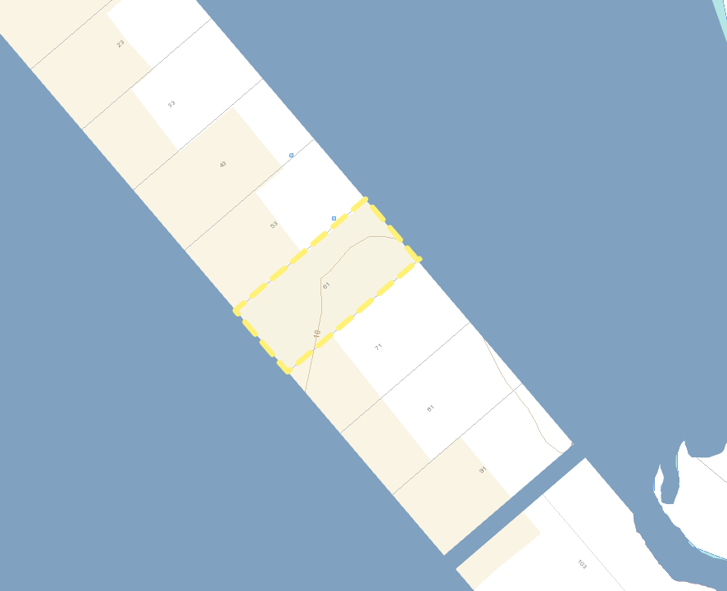
Figure 6. Crown Land Map. Source: NSW Planning Portal

4. Proposed Development

This Development Application seeks consent for the following:
- Demolition of existing structures comprising two residential dwellings, sheds and stables, and tree removal
- Construction of 2x two storey stables containing 75 horse stabling boxes in each building (150 stables in total)
- Construction of a waste and storage shed
- Construction of an at-grade car park comprising 40 car parking spaces, a loading zone, a drop-off zone, 8 truck parking spaces and a turning circle
- Construction of ancillary horse training facilities including:
  - 4x 12-horse walking machines
  - 8x sand rolls
  - 8x wash bays
  - 16 tie-up stalls
- Construction of a pump room, 4x rainwater tanks and a BBQ gazebo
- Use of the site as an animal training and boarding establishment
- Civil works including reconstruction of Rickaby Street, earthworks, stormwater management works comprising a pit and pipe network and absorption trench
- Remediation works
- Landscaping works

Each of the above items are discussed further under the relevant headings below. Figure 7 below is an extract of the site plan for the proposed development.

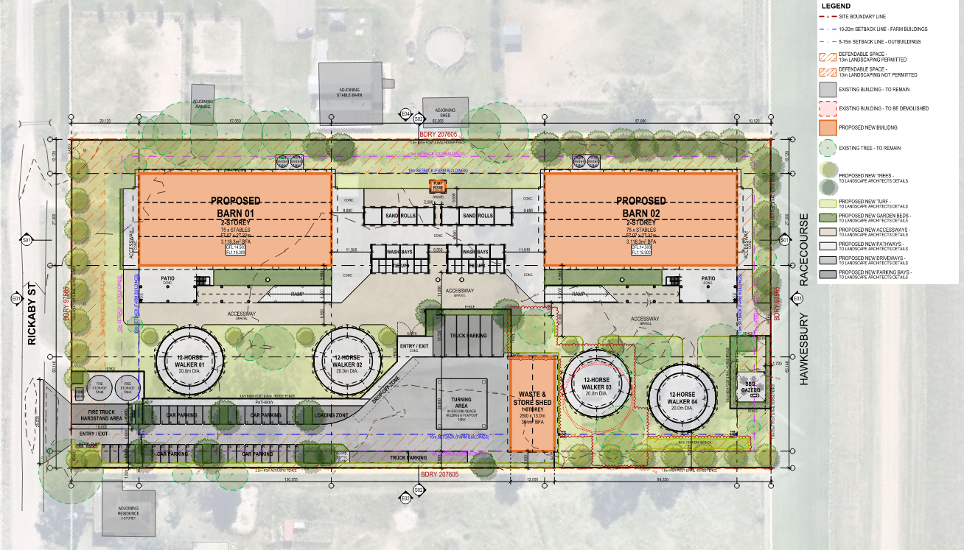
Figure 7. Proposed Site Plan. Source: EJE Architecture

4.1 Demolition and Tree Removal
Demolition is proposed for improvements on the subject site which includes the following:
- Demolition of 2x dwelling houses, 3x stable barns, 6x sheds and 2x awnings
- Removal of all improvements to the land including driveways, paths, fences (excluding the boundary fences), water tanks, septic tanks and utility services.
Figure 8 below provides an overview of the structures proposed to be demolished/removed from the site.

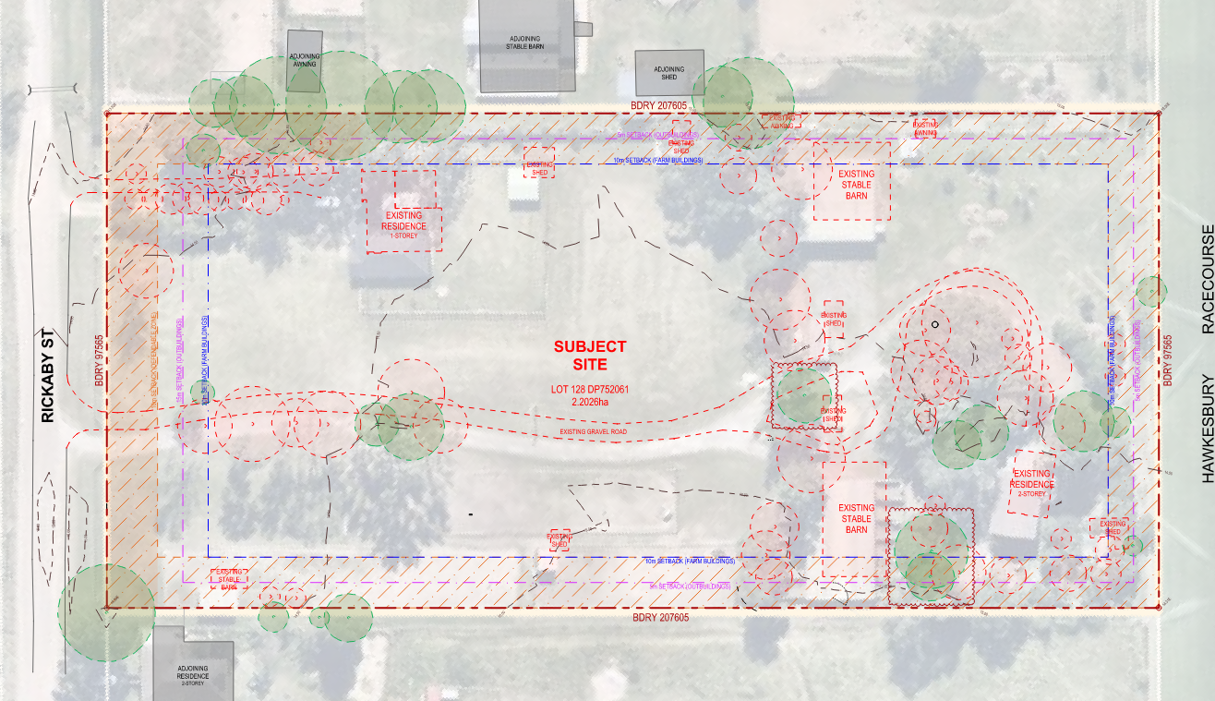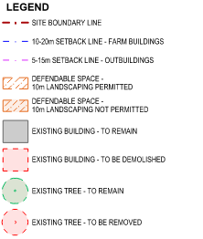
Figure 8. Proposed Site Plan. Source: EJE Architecture

Consent is also sought for the removal of trees and vegetation required to facilitate the earthworks and remediation. The subject site and associated vegetation are not identified on the Biodiversity Values Map under the Biodiversity Conservation Act 2016 or the Terrestrial Biodiversity Map under Hawkesbury LEP. A total of 48 trees are proposed to be removed which is supported by an Arboricultural Impact Assessment (AIA) prepared by Arborlogix submitted with the application.

The AIA supports the removal of the 48 trees due to their low retention values and/or conflict with the proposed development design, and recommends that all medium and high retention value trees onsite be replaced with tree species that will have a similar sized canopy at maturity. The landscape plans prepared by Terras submitted with this application provide adequate replacement trees which is discussed in section 4.4 below.

4.2 Built Form
The proposed built form associated with the animal boarding and training establishment comprises two main buildings being the stable barns, with associated smaller buildings to support the operations of the proposed development.

The proposed structures on the site comprise the following:
- 2x two storey stable barns surrounded by concrete pathways and connected by a concrete forecourt with sand rolls, wash bays and tie ups between the barns. Each barn is connected to two rainwater tanks, has a concreted patio and a ramp from the ground level providing access to the first-floor stable boxes.
- 4x horse walkers with a diameter of 20m and capable of holding 12 horses each
- 1x single storey waste and storage shed comprising 4x bays, each with 2 roller doors (8 in total) providing through access
- 2x fire storage tanks and a fire pump located adjacent the vehicle entry to the site at the front boundary
- 1x BBQ gazebo at the rear of the site

A detailed description of each proposed building/structure is provided below.

Barn 1
- Ground Floor – 27x horse stabling boxes, 2x wash bays, 2x store rooms, 1x feed store, 1x staff room, 1x tack/laundry and 2x water closets
- First Floor – 26x horse stabling boxes, 3x wash bays, 2x store rooms, 1x feed store, 1x tack/laundry and 2x water closets

Barn 2
- Ground Floor – 27x horse stabling boxes, 2x wash bays, 2x store rooms, 1x feed store, 1x staff room, 1x tack/laundry and 2x water closets
- First Floor – 37x horse stabling boxes, 3x wash bays, 2x store rooms, 1x feed store, 1x tack/laundry and 2x water closets

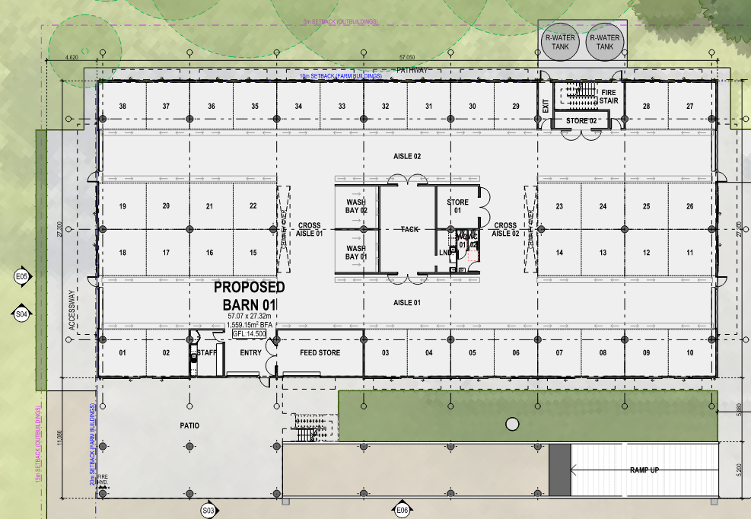 | 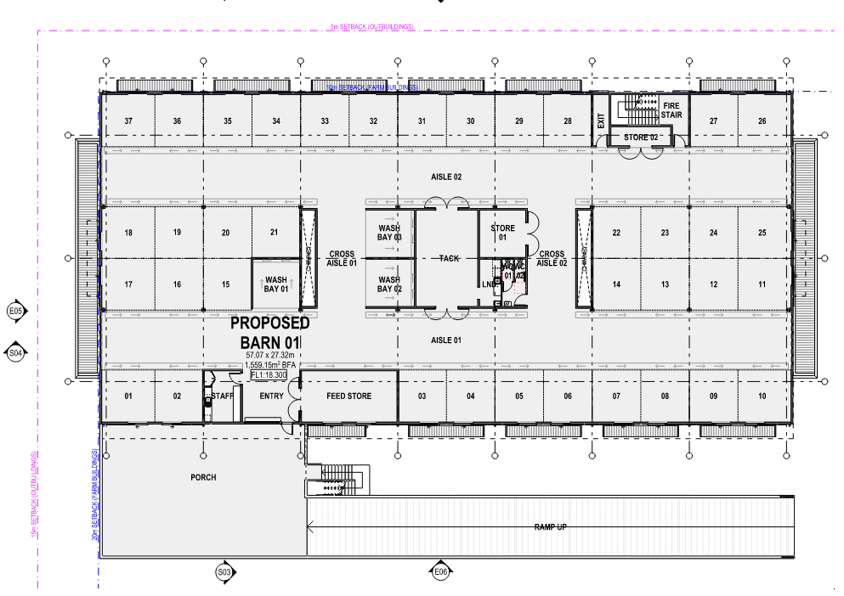
Figure 9. Barn 1 Ground Floor Plan.  Source: EJE Architecture | Figure 10. Barn 1 First Floor Plan.  Source: EJE Architecture
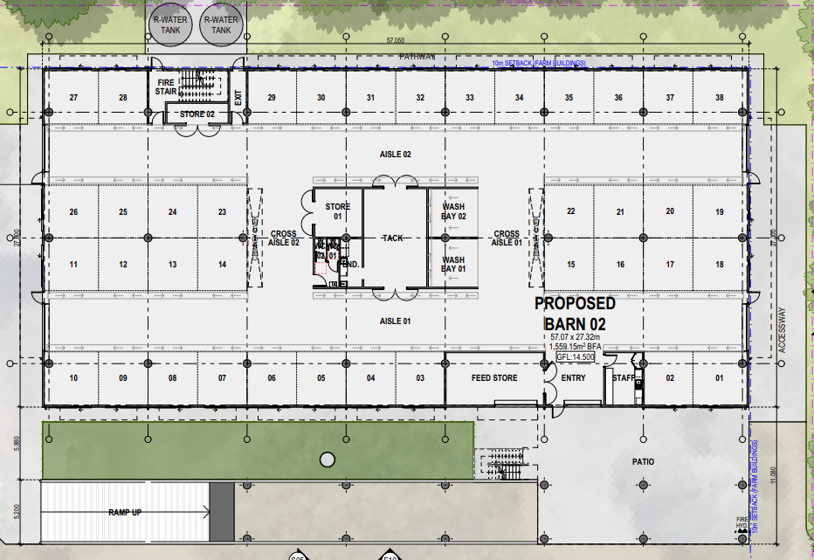 | 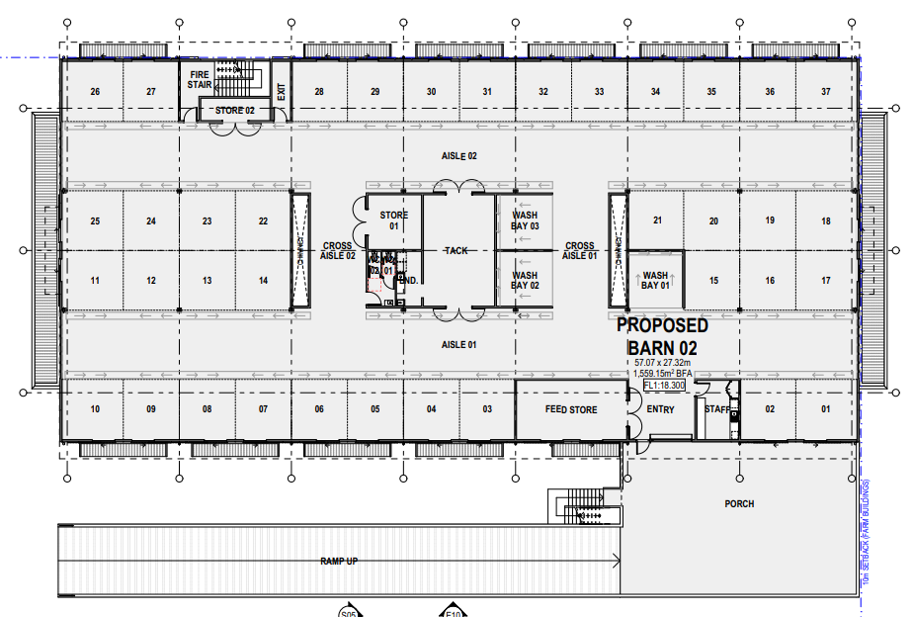
Figure 11. Barn 2 Ground Floor Plan.  Source: EJE Architecture | Figure 12. Barn 2 First Floor Plan.  Source: EJE Architecture

The proposed barns being two storey in height and having a void area for ventilation results in the two buildings exceeding the maximum height of buildings permitted on the subject site under clause 4.3 of Hawkesbury LEP by up to 1.25m. The application is accompanied by a request to vary the maximum height of buildings development standard using clause 4.6 of Hawkesbury LEP. This is discussed further in section 7.

Wash bays, tie ups and sand rolls
Between the stable barn buildings, the proposal includes a hardstand area containing wash bays, tie ups and sand rolls as illustrated in Figure x below.

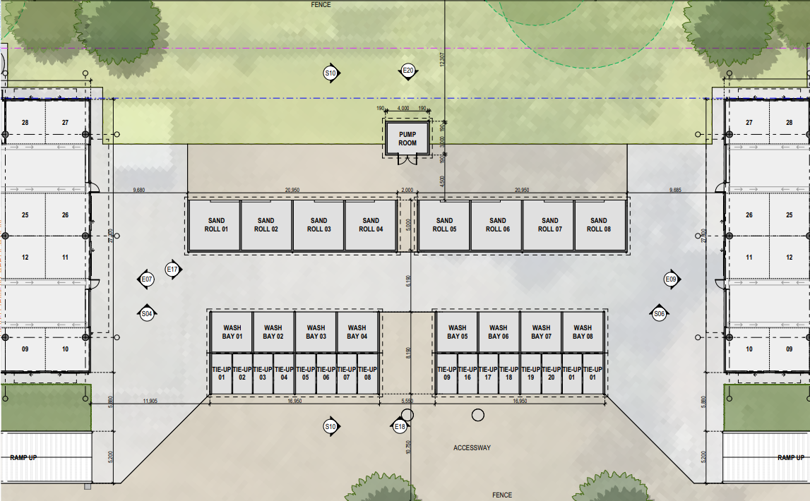
Figure 13. Wash Bays, Tie ups and Sand Rolls Plan.
Source: EJE Architecture

Horse walkers
The proposal includes construction of 4x horse walkers across the site, each with capacity for 12 horses.

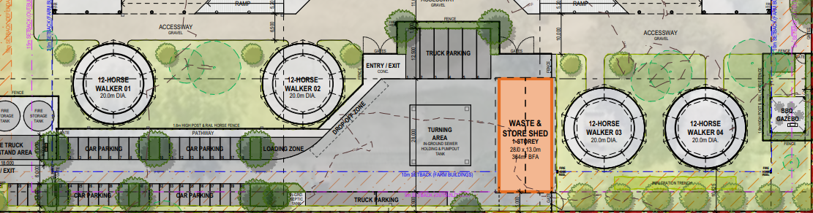
Figure 14. Horse Walkers illustrated on the Site Plan.
Source: EJE Architecture

Waste and store shed
The waste and store shed is a single storey building comprising 4x separate waste/store areas. Each bay has 2x roller doors to provide through access as illustrated in Figures 15 and 16 below.

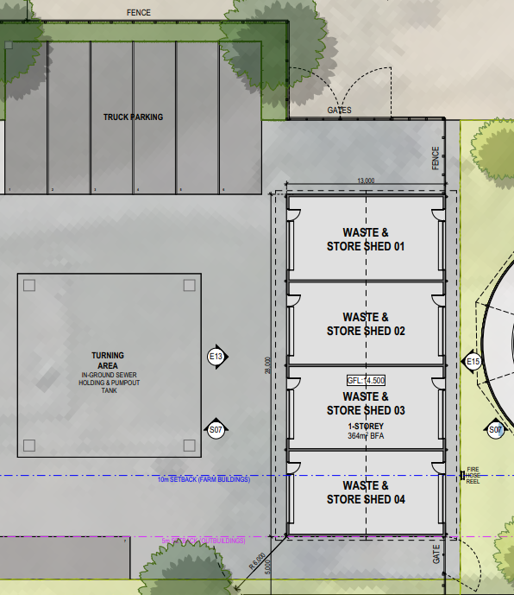 | 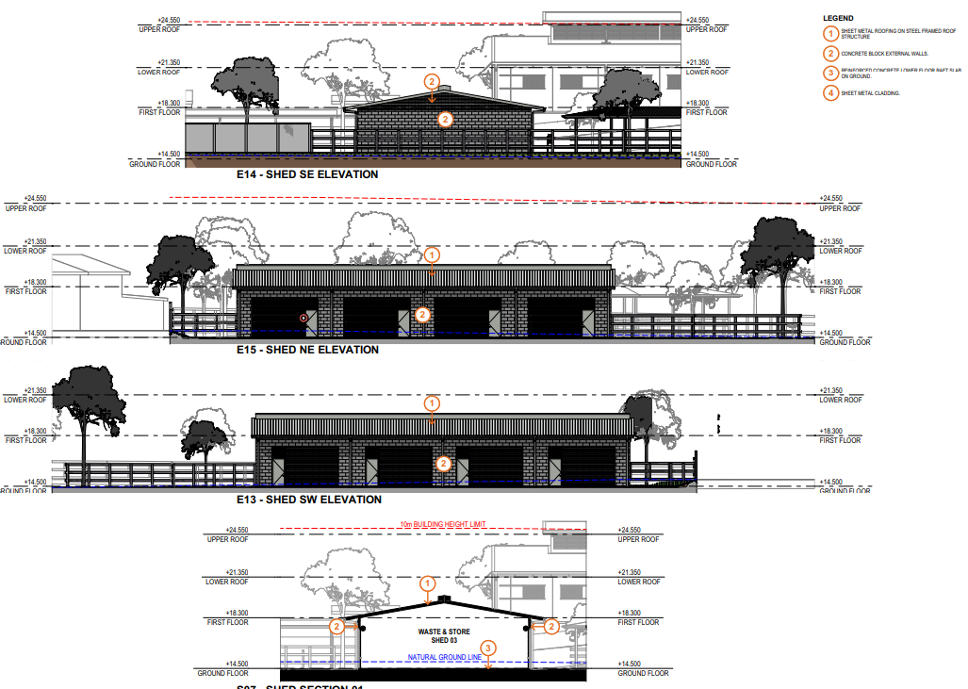
Figure 15. Waste & Store Plan.  Source: EJE Architecture | Figure 16. Waste & Store Elevation/Section Plan.  Source: EJE Architecture

Fire pump tanks and BBQ gazebo
The proposal also includes two separate areas to house the fire storage tanks and pump which is located at the front boundary of the site, and the BBQ gazebo located at the rear of the site. The fire pump tanks are provided to comply with the Building Code of Australia and relevant Australian Standards.

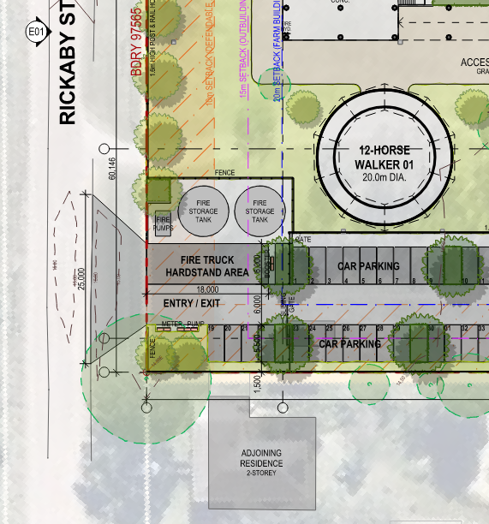 | 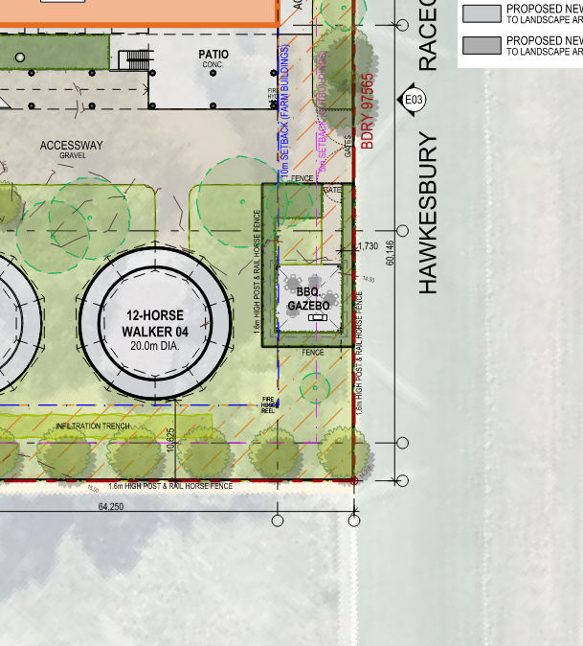
Figure 17. Fire Storage Tanks and Pump.  Source: EJE Architecture | Figure 18. BBQ Gazebo.  Source: EJE Architecture

4.2 Civil Works
Consent is sought for civil works to facilitate the proposed development including the following:
- Earthworks comprising 1.05m of fill and 0.75m of cut to establish suitable gradients for construction and stormwater management

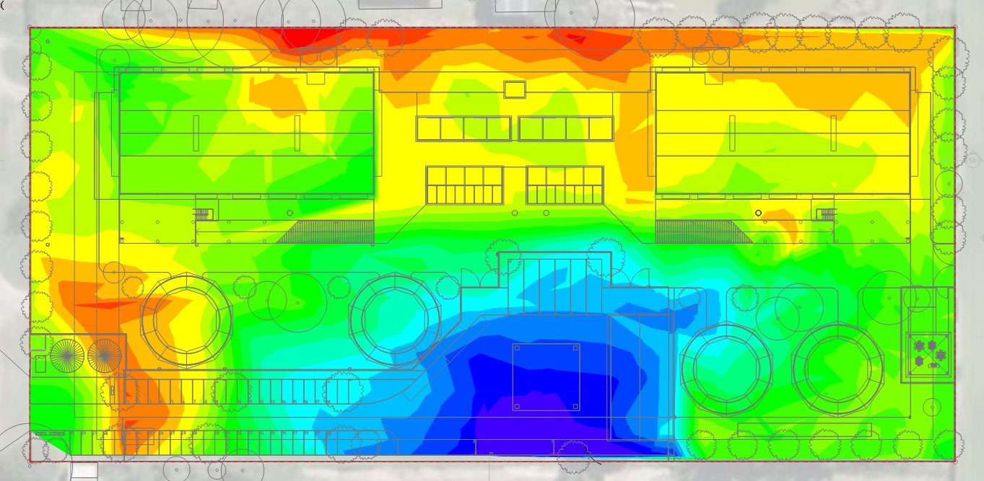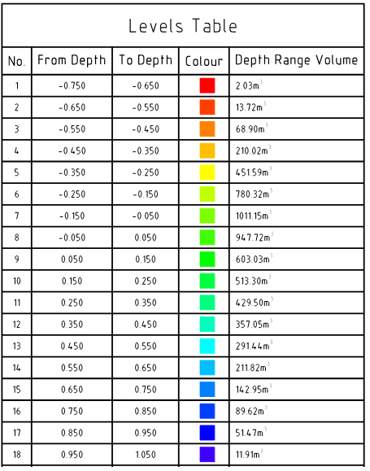
Figure 19. Cut and Fill Plan.
Source: WSce

- Stormwater management works including construction of a pit and pipe network providing drainage to the northeastern corner of the site where stormwater is discharged to Rickaby Street. The proposed stormwater management associated with the proposal includes reconstruction of a headwall and culvert in Rickaby Street to minimise concentrated flows at a single location. An absorption trench is proposed in the north western corner of the site to treat flows from the rear part of the site.

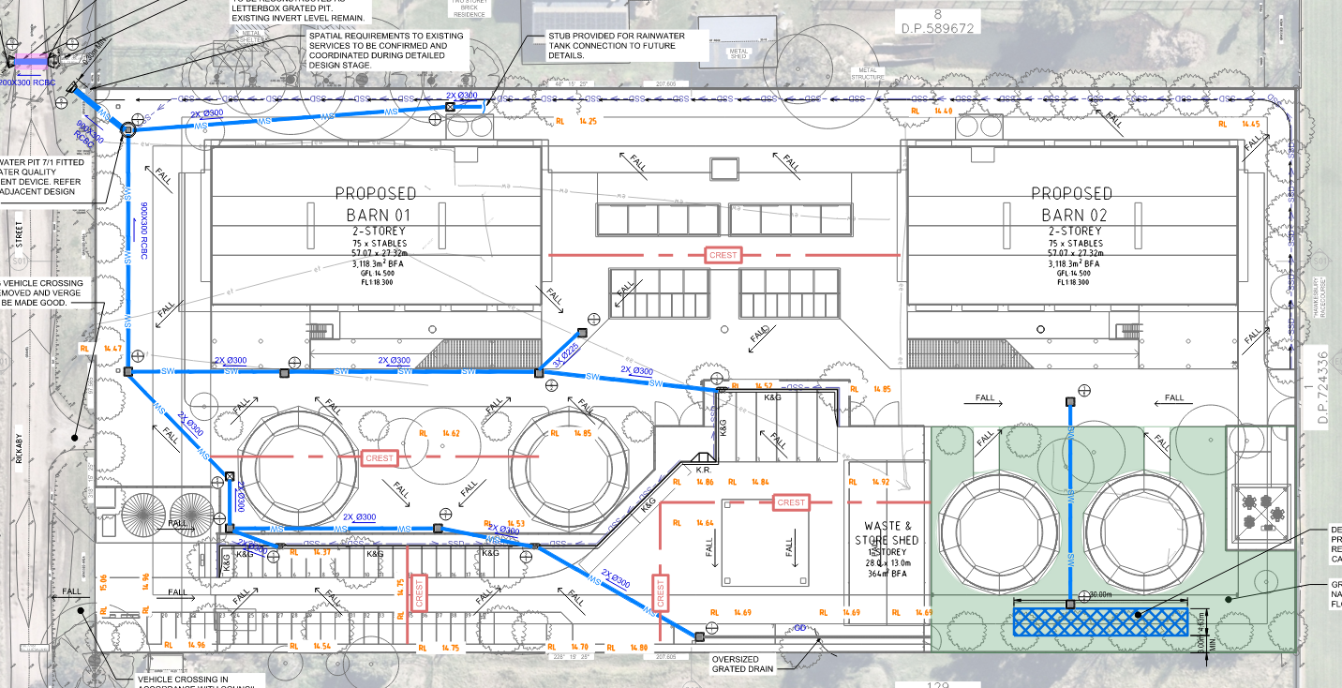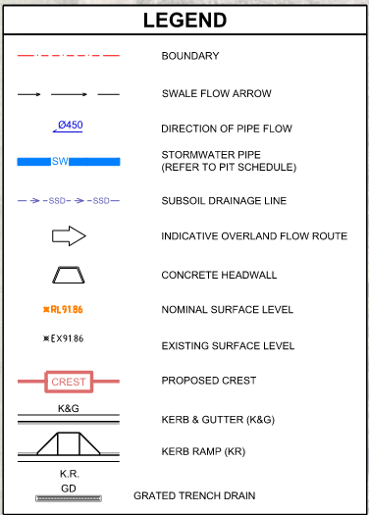
Figure 20. Stormwater Management Plan.
Source: WSce

- The proposal seeks consent for the reconstruction of Rickaby Street, a road owned and managed by Crown Lands NSW. The works proposed within Rickaby Street include the widening of the existing sealed road to provide a 6m wide carriageway from the intersection at Racecourse Road up to the boundary of the subject site where it adjoins 71 Rickaby Street.

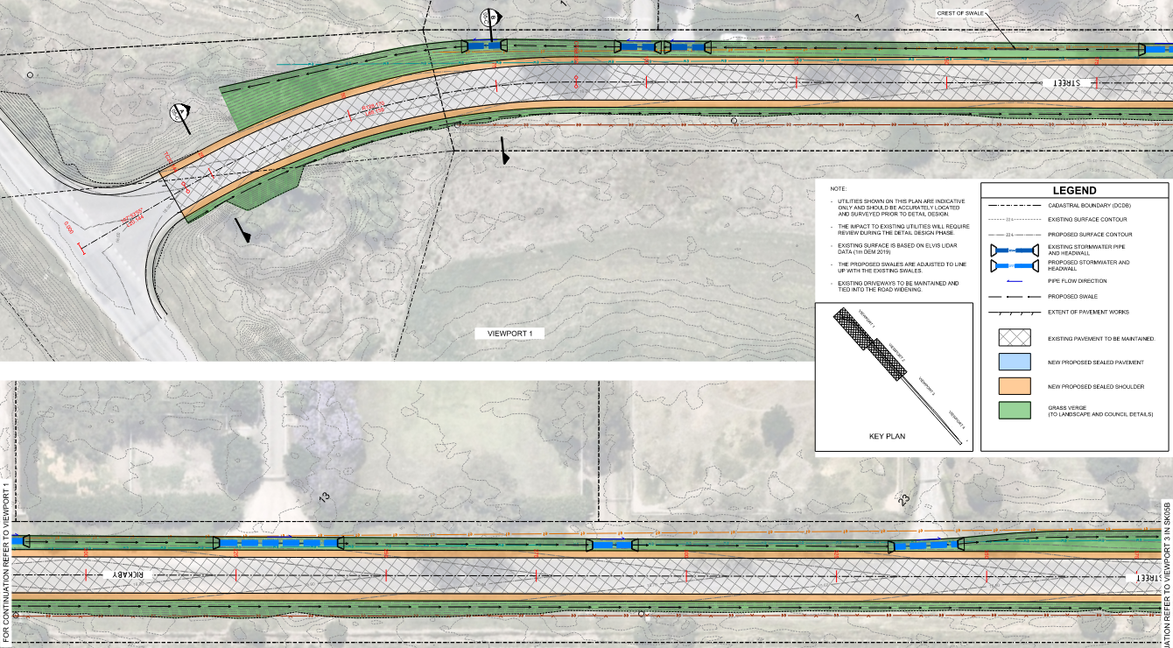

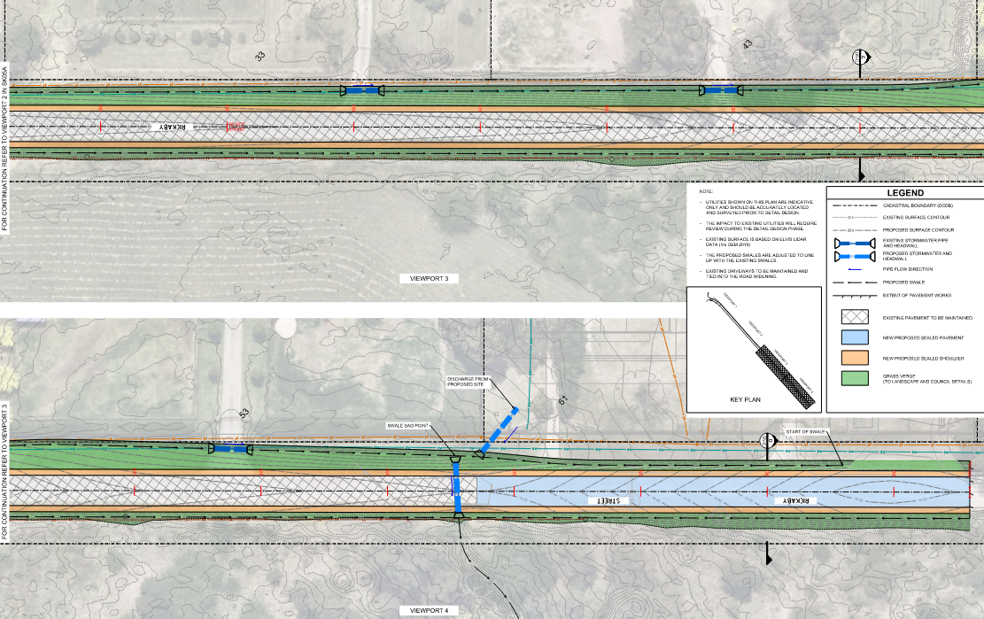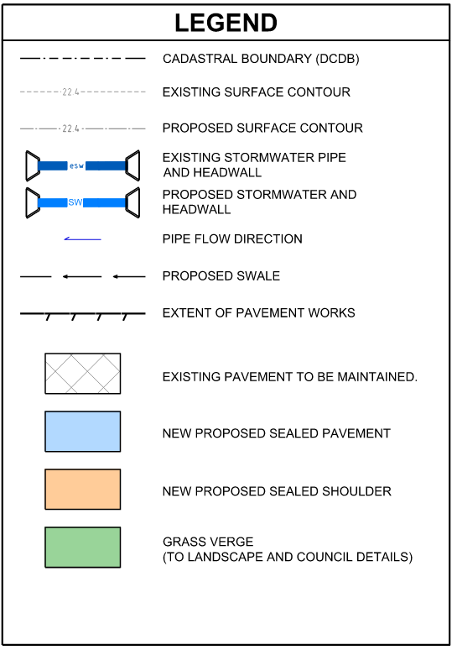
Figure 21. Plans illustrating the extent of roadworks in Rickaby Street.
Source: WSce

4.3 Remediation Works
Consent is sought for the remediation of the contaminated areas identified in the Detailed Site Investigation (DSI) prepared by Douglas Partners dated 24 November 2024. The investigations by Douglas Partners identified the following:
- Zinc in test pit 117 exceeded the ecological investigation levels established under National Environment Protection (Assessment of Site Contamination) Measure 1999 (NEPM).
- Asbestos Fines/Fibrous Asbestos (AF/FA) in test pit 112 which exceeded the AF/FA criterion.
- Asbestos-containing material (ACM) fragments on the surface or in shallow soils at test pits 110, 112, 113 and stockpile 2 and bore hole 111.

The application is supported by a Remediation Action Plan (RAP) prepared by Douglas Partners dated 10 January 2025 which sets out the particulars of remediation works. The RAP offers various options for the remediation of the contaminated areas of the site and a requirement for validation reporting to be prepared by the consultant following the remediation of the site.

4.4 Landscaping Works
The application is accompanied by detailed landscape plans prepared by Terras Landscape Architects, which details the various small, medium and large plantings proposed across the site. The proposal seeks consent for landscaping works, including the planting of 48 supplementary replacement trees to be planted throughout the site, capable of reaching a height at maturity between 8m and 15m.

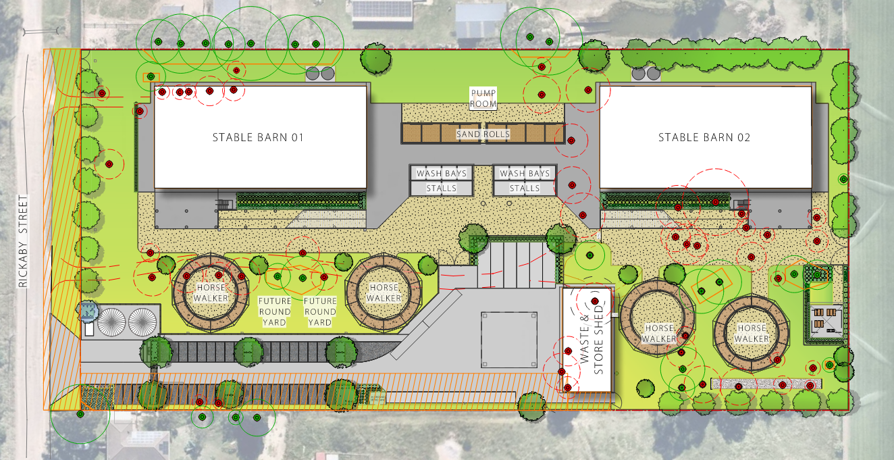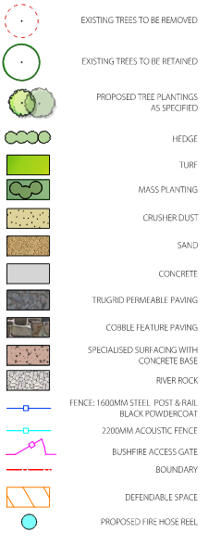
Figure 22. Proposed Landscaping Plan.
Source: Terras Landscape Architects

5. Application History

Date | Comment
25/01/2025 | Application formally lodged on the NSW Planning Portal (as per DA Form).
10/02/2025 – 24/02/2025 | Application placed on public advertising
30/04/2025 | Council requests additional information
03/07/2025 | Additional information provided to address Council’s request for additional information.
01/09/2025 | Further information provided to address reconstruction of Rickaby Street

6. Referrals

Stakeholder | Comment
Parks & Ecology | Supported subject to the imposition of conditions.
Engineering | Supported subject to the imposition of conditions, including a deferred commencement condition.
Environment and Regulatory services | Supported subject to the imposition of conditions, including a deferred commencement condition.
Building Surveyor | Supported subject to the imposition of conditions.
SMF Officer | Supported subject to the imposition of conditions.

7. Environmental Planning Instruments

7.1 Overview

The instruments applicable to this application are:
- Environmental Planning and Assessment Act 1979;
- Environmental Planning and Assessment Regulations 2021;
- State Environmental Planning Policy (Biodiversity & Conservation) 2021 ;
- State Environmental Planning Policy (Resilience & Hazards) 2021;
- State Environmental Planning Policy (Transport & Infrastructure) 2021;
- Hawkesbury Local Environmental Plan 2012 (LEP 2012);
- Hawkesbury Development Control Plan 2002 (HDCP 2002); and
- Hawkesbury Council Flood Policy 2020

7.2 Environmental Planning and Assessment Act 1979

The application has been assessed relative to Section 4.15 of the Environmental Planning and Assessment Act 1979, taking into consideration the objects of the Act and all relevant state and local planning controls. The relevant instruments for consideration under the Environmental Planning and Assessment Act 1979 are addressed below.

7.7 State Environmental Planning Policy (Biodiversity and Conservation) 2021.

7.7.1 Chapter 2 – Vegetation in Non-Rural Areas

State Environmental Planning Policy (Biodiversity and Conservation) 2021 (Biodiversity and Conservation SEPP) regulates clearing that is not ancillary to development requiring consent. Whereas, clearing that is ancillary to development requiring consent will be assessed as part of the development assessment process. The area of proposed works is in a predominately cleared area of the site. However, there are works located in proximity of existing trees, including those within adjoining properties.

The application is supported by an Ecological Assessment Report prepared by Anderson Environment & Planning which determines that the vegetation on site is a mix of planted native and exotic species with little to mid-stratum and a heavily grazed ground layer. The vegetation on the site provides minimal opportunity for threatened flora and fauna to utilise the site based on the current land use. Council’s Parks Officer has reviewed the and provided raised no objections to the assessment undertaken.

As a result, the proposed removal of 48 trees as identified in the Arboricultural Impact Statement (AIS) prepared by Aborlogix (dated 13 June 2025) is supported. Elsewhere, the proposed retention of 25 trees on the subject site and adjoining sites is also supported subject to compliance with the recommendations of the AIS.

Chapter 4 – Koala Habitat Protection 2021.

Chapter 4 aims to protect koala habitat, streamline the assessment process for development applications situated in areas not covered by a comprehensive plan of management and ensure the consistent use of criteria to protect koala habitat across the state. Desktop assessment of local records shows that koala records in the area are sparse and only one sighting observed within the assessment buffer (1.5km) in 2013 approximately 1.1km northeast of the subject site, and another in 1949 approximately 2.9km northeast of the subject site. Based on local records and degraded habitat, the Ecological Assessment Report prepared by Anderson Environment & Planning confirms that it is unlikely that the site would part of a natural range of Koalas, and does not constitute core koala habitat. No evidence of Koalas was observed during surveys.

7.7.2 Chapter 6 – Water catchments
The Site is within the Hawkesbury Nepean River Catchment and as such the provisions of the Chapter 6 apply. Chapter 6 aims to provide a strategic planning framework for environmental management associated with all new development in the catchment.

The proposed animal boarding and training establishment and associated works are not anticipated to have any adverse impacts on the water catchment with suitable sediment and erosion control measures proposed to be installed throughout the construction of the development. An assessment against Chapter 6 of the B&C SEPP has been undertaken below:

Clause | Comment
Part 6.2 Development in Regulated Catchments
6.6 Water quality and quantity | Council’s Development Engineers have raised no objection to the proposed development from a water quality and quantity perspective.
6.7 Aquatic Ecology | There is no aquatic foraging habitat within the site and the proposal is not anticipated to have an adverse impact on any aquatic ecology outside the subject site.
6.8 Flooding | Council’s engineers have reviewed the application and noted that the proposal can be supported subject to the imposition of conditions.
6.9 Recreation and Public Access | The proposed development does not seek to introduce any new changes with regard to public access to and from natural waterbodies.
6.10 Total Catchment Management | Noted, Council engineers upon their review do not expect an adverse environmental impact.
6.11 Land within 100m of natural water body | No water-dependent uses are proposed.
6.12 Riverine scenic area | The subject site is not located within a riverine scenic area.
6.13 Hawkesbury-Nepean conservation area sub catchments | The subject site is within Hawkesbury-Nepean conservation area sub-catchments and this application seeks consent for works under Clause 6.13.  The development will minimise human interference and maintain the structure and floristics of native vegetation in the sub-catchment. The development will not impact the scenic quality of the locality. Development has previously been carried out on the development site for agricultural uses and therefore complies.
6.16 Artificial waterbodies | The proposed development does not seek consent for an artificial waterbody.
6.21 Stormwater management | The proposed development includes works that will collect, channel and disperse stormwater runoff from the subject site. Council’s Development Engineers have reviewed the proposed development and are satisfied that the proposed development is unlikely to result in any detrimental impacts on the Hawkesbury-Nepean catchment.

7.8 State Environmental Planning Policy (Resilience and Hazards) 2021
The requirements of State Environmental Planning Policy (Resilience and Hazards) 2021 (Resilience and Hazards SEPP) apply to the subject site. In accordance with Chapter 4 of the Resilience and Hazards SEPP, Council must consider if the land is contaminated, if it is contaminated, is it suitable for the proposed use and if it is not suitable, can it be remediated to a standard such that it will be made suitable for the proposed use.

Remediation works are proposed as part of this application. Subject to the processes outlined within the DSI and RAP, the site will be made suitable for the proposed animal boarding and training establishment. The proposed remediation measures include various options for the remediation of contaminated material including the following:

- On-site treatment so that the contaminants are destroyed or the risk is reduced to an acceptable level,
- Off-site treatment so that the contaminants are destroyed or the risk is reduced to an acceptable level, or
- Consolidation and isolation of the soil on-site by containment with a properly designed barrier;
- Removal of contaminated material to an approved site or facility, followed, where necessary, by replacement with appropriate material; or
- Where the assessment indicates remediation would have no net environmental benefit or would have a net adverse environmental effect, implementation of an appropriate management strategy.

Council’s Environmental Health Officers have reviewed the submitted material and raise no concerns with the remediation approach, subject to the imposition of conditions of consent.

7.9. State Environmental Planning Policy (Transport and Infrastructure) 2021.
The relevant matters to be considered under Chapter 2 of State Environmental Planning Policy (Transport and Infrastructure) 2021 (Transport and Infrastructure SEPP) for the proposed development outlined below.

Clause | Comment
Clause 2.48 – Electricity Infrastructure | The proposed development is not considered to be within the vicinity of any electricity infrastructure under Clause 2.48 (1).
Clause 2.98 – Development Adjacent to rail corridors | The proposed development does not adjoin in, around or on top of any rail corridors.
Clause 2.119 – Frontage to a classified road | The proposed development does not front a classified road.
Clause 2.120 – Impact of road noise or vibration on non-road development | The subject site does not adjoin a classified road.
Clause 2.122 – Traffic generating development | The proposed development is not identified as traffic generating development.

7. Hawkesbury Local Environmental Plan 2012

The relevant matters considered under the Hawkesbury Local Environmental Plan 2012 for the proposed development are outlined below:

8.1. Clause 1.2 Aims of plan.

“(aa) to protect and promote the use and development of land for arts and cultural activity, including music and other performance arts,
- to provide the mechanism for the management, orderly and economic development and conservation of land in Hawkesbury.
- to provide appropriate land in area, location and quality for living, working and recreational activities and agricultural production,
- to protect attractive landscapes and preserve places of natural beauty, including wetlands and waterways,
- to protect and enhance the natural environment in Hawkesbury and to encourage ecologically sustainable development,
- to conserve and enhance buildings, structures and sites of recognised significance that are part of the heritage of Hawkesbury for future generations,
- to provide opportunities for the provision of secure, appropriate and affordable housing in a variety of types and tenures for all income groups in Hawkesbury,
- to encourage tourism-related development that will not have significant adverse environmental effects or conflict with other land uses in the locality.”

The proposed animal boarding and training establishment is considered to align with the aims of the plan under clauses (a), (b) & (g).

8.2. Clause 2.3 Zone objectives and Land use table.

The site is zoned RU4 Primary Production Small Lots under the Hawkesbury LEP. The objectives of the RU4 zone are:
- To enable sustainable primary industry and other compatible land uses.
- To encourage and promote diversity and employment opportunities in relation to primary industry enterprises, particularly those that require smaller lots or that are more intensive in nature.
- To minimise conflict between land uses within this zone and land uses within adjoining zones.
- To ensure that development occurs in a way that does not have a significant adverse effect on water catchments, including surface and groundwater quality and flows, land surface conditions and important ecosystems such as waterways.

The proposed development is considered to be reflective of the above objectives.

The proposed development is for an animal boarding and training establishment which is defined as:

animal boarding or training establishment means a building or place used for the breeding, boarding, training, keeping or caring of animals for commercial purposes (other than for the agistment of horses), and includes any associated riding school or ancillary veterinary hospital.

The proposed animal boarding and training establishment is a use that is permissible with consent in the RU4 zone.

Clause | Comment
Part 4 – Principal development standards
Clause 4.1 Minimum subdivision lot size | The application does not include subdivision works.
Clause 4.2 Rural subdivision | N/A
Clause 4.3 Height of Buildings | The subject site has a maximum permissible building height of 10m. The proposed development seeks consent for a building with a height of up to 11.25m.
Clause 4.4 Floor Space Ratio | There is no maximum floor space ratio applicable on the subject site.
Clause 4.6 Exceptions to development standards | The proposal seeks a variation to Clause 4.3, as above. A Clause 4.6 Written Request has been submitted by the applicant. A detailed assessment can be found further below.
Part 5 – Miscellaneous provisions
Clause 5.10 Heritage Conservation | The subject site does not contain any heritage items, is not located within a heritage conservation area, and is not in close proximity (1km radius of the subject site) of any heritage items.
Clause 5.21 Flood planning | The subject site is identified as being affected by flooding in the 5%, 2% and 1% AEP flood events. An assessment has been undertaken by GRC Hydro and includes a detailed assessment against the requirements of clause 5.21 of Hawkesbury LEP, confirming the proposal complies with the relevant requirements. Council’s Development Engineer has reviewed the proposal and confirms the proposal is satisfactory from a flooding perspective.
Part 6 – Additional local provisions
Clause 6.1 Acid sulphate soils | The site is mapped as Class 5 Acid Sulfate Soils on the Acid Sulfate Soils Map. The Geotechnical Report prepared by Douglas Partners notes that acid sulfate soils typically occur at levels of RL 5 or below. The nearest mapped ‘high probability of occurrence’ of ASS is in Hawkesbury River, which is approximately 2.7 km north-east of the site. Appropriate conditions of consent can be recommended.
Clause 6.2 Earthworks | Council’s development engineers have reviewed the proposed earthworks involved and support the application subject to the imposition of conditions.
Clause 6.4 Terrestrial biodiversity | The subject site does not contain any land identified on the Terrestrial Biodiversity Map in Hawkesbury LEP.
Clause 6.6 Development in areas subject to aircraft noise | The site is not considered to fall within the vicinity of the RAAF base Richmond.
Clause 6.7 Essential services | The subject site is appropriately serviced. The nature of the development will not place unnecessary strain on these services.

Clause 4.6 Exceptions to development standards

Description of non-compliance

Development Standard: | Clause 4.3 - Building height
Requirement: | 10 metres
Proposed: | 11.25 metres
Percentage variation to requirement: | 12.5%

Assessment of request to vary a development standard:

The variation sought to Clause 4.3 maximum height of building is considered having regard to the provisions contained in Clause 4.6 of the Hawkesbury Local Environmental Plan 2012 as follows:

The following assessment of the variation to maximum building height under Clause 4.3 of the Hawkesbury Local Environmental Plan 2011, has taken into consideration the recent judgement contained within Initial Action Pty Ltd v Woollahra Municipal Council [2018] NSWLEC 118, Baron Corporation Pty Limited v Council of the City of Sydney [2019] NSWLEC 61, and RebelMH Neutral Bay Pty Limited v North Sydney Council [2019] NSWCA 130.

Clause 4.6 Exceptions to development standards:

- The objectives of this clause are as follows:
- to provide an appropriate degree of flexibility in applying certain development standards to particular development,
- to achieve better outcomes for and from development by allowing flexibility in particular circumstances.”

- Development consent may, subject to this clause, be granted for development even though the development would contravene a development standard imposed by this or any other environmental planning instrument. However, this clause does not apply to a development standard that is expressly excluded from the operation of this clause.”

Comment:

The Clause 4.3 Height of buildings development standard is not expressly excluded from the operation of this clause.

- Development consent must not be granted for development that contravenes a development standard unless the consent authority has considered a written request from the applicant that seeks to justify the contravention of the development standard by demonstrating:
- that compliance with the development standard is unreasonable or unnecessary in the circumstances of the case, and
- that there are sufficient environmental planning grounds to justify contravening the development standard.

- Development consent must not be granted for development that contravenes a development standard unless:
- the consent authority is satisfied that:
the applicant’s written request has adequately addressed the matters required to be demonstrated by subclause (3), and
the proposed development will be in the public interest because it is consistent with the objectives of the particular standard and the objectives for development within the zone in which the development is proposed to be carried out, and
- the concurrence of the Secretary has been obtained.”

Clause 4.6 (3) (Justification) assessment:

Clause 4.6 (4)(a)(i) requires the consent authority to be satisfied that the applicant’s written request, seeking to justify the contravention of the development standard, has adequately addressed the matters required to be demonstrated by Clause 4.6(3). There are two separate matters for consideration contained within Clause 4.6(3) and these are considered as follows:

- that compliance with the development standard is unreasonable or unnecessary in the circumstances, and

The Applicant’s written request states that compliance with the development standard is unreasonable or unnecessary in the circumstances of the case on the following grounds:
Key Question | Response
a) Are the objectives of the development standard achieved notwithstanding the non-compliance? | “The objectives of clause 4.3 of the HLEP are addressed as follows:  (a) to protect privacy and the use of private open space in new development and on adjoining land,  The proposed development, as noted within the SEE, has been designed to protect the privacy and limit the impact of the development on adjoining land. As is discussed in depth below, the exceedance in height is located in the centre of the stables, is setback from the respective boundaries, represents non-habitable space and therefore results in negligible privacy impacts to adjoining land and private open space compared to a complying scheme.  (b) to minimise the impact of overshadowing, visual impact and loss of privacy on adjoining properties and  open space areas,  The non-conforming portion of the building height is confined to the centre of the stables, which results in negligible impacts from an overshadowing, visual impact and privacy perspective to adjoining properties and open space areas.  From a shadow perspective, it is noted that shadow arising from the height exceedance is confined to the Rickaby Street road reserve or the site itself, with no shadow falling on any neighbouring properties or areas of open space.  Detailed consideration has been made to ensure that adequate privacy is provided to surrounding development. The proposed stable is located in the north western portion of the site. The neighbouring development adjoining the site to the north west is used for a horse stabling facility of similar operation to the proposed development, therefore there is no impact on residential development, sensitive land uses or areas of open space. Notwithstanding, it is noted that the proposed development adopts suitable setbacks in accordance with the relevant DCP requirements with the non-complying portion setback further from the building edge than what is otherwise required, and represents non-habitable area (designed for ventilation purposes only) therefore resulting  in negligible privacy impacts associated with the non-complying portion of the buildings.  Further, the extent of the non-compliance is not considered to give rise to any visual impact from the loss of key site lines to or form areas of visual importance. This is because the extent of the variation relates only to the pitch roof form which varies between 1m -1.25m in height and does not represent a full storey.  (c) to nominate heights that will provide a transition in built form and land use intensity,  The lots surrounding the site have a HOB control of 10m, therefore the height control does not intend to transition built from and intensity from one site to another.  (d) to ensure an appropriate height transition between new buildings and heritage items.  The site is not located within the vicinity of heritage items. This objective is therefore irrelevant for this development.
b) Are the underlying objectives or purpose  of the development standard not relevant  to the development? (Give details if  applicable) | Not relied upon.
c) Would the underlying objective or purpose be defeated or thwarted if compliance was required? (Give details if applicable) | The objectives of the land use zone applying to the site, being the RU4 Primary Production Small Lots zone, aims to enable sustainable primary industries which promote diversity and employment opportunities.  The proposal, if required to be delivered within a compliant building height, would limit the proposals’ ability to deliver on the objectives of the applicable land use zone, with a reduction in individual horse stables resulting in a subsequent reduction in staffing numbers. Further, the built form that is located above the HOB plane is primarily for equine welfare and ventilation purposes to the lower ground due to the two-storey nature of the stables. The reduction in the number of horse stables, which would have the effect of removing the second storey, would also likely render the proposal unfeasible and unable to proceed.  The proposed development is a built form that is consistent with the surrounding context, whereby primary industry uses are provided, providing employment opportunities for the greater Clarendon area. This is also consistent with Council’s strategic land use planning and namely the Hawkesbury Rural Lands Policy which seeks to protect and support the expansion of the horse stud sector.
d) Has the development standard been virtually abandoned or destroyed by the Council’s own actions in granting consent departing from the standard? | Not replied upon.
e) Is the zoning of the land unreasonable or inappropriate so that the development standard is also unreasonable to unnecessary? | Not relied upon.

Council response

This assessment concurs with the justification provided by the applicant above.

- that there are sufficient environmental planning grounds to justify the contravention of the development standard.

Comment:
In the matter of Initial Action Pty Ltd v Woollahra Municipal Council [2018] NSWLEC 118, Preston CJ provides the following guidance (para 23) to inform the consent authority’s finding that the applicant’s written request has adequately demonstrated that that there are sufficient environmental planning grounds to justify contravening the development standard:

“As to the second matter required by cl 4.6(3)(b), the grounds relied on by the applicant in the written request under cl 4.6 must be “environmental planning grounds” by their nature: see Four2Five Pty Ltd v Ashfield Council [2015] NSWLEC 90 at [26]. The adjectival phrase “environmental planning” is not defined, but would refer to grounds that relate to the subject matter, scope and purpose of the EPA Act, including the objects in s 1.3 of the EPA Act.’”

Section 1.3 of the EPA Act reads as follows:

“1.3 Objects of Act (cf previous s 5)
The objects of this Act are as follows:

- to promote the social and economic welfare of the community and a better environment by the proper management, development and conservation of the State’s natural and other resources,
- to facilitate ecologically sustainable development by integrating relevant economic, environmental and social considerations in decision-making about environmental planning and assessment,
- to promote the orderly and economic use and development of land,
- to promote the delivery and maintenance of affordable housing,
- to protect the environment, including the conservation of threatened and other species of native animals and plants, ecological communities and their habitats,
- to promote the sustainable management of built and cultural heritage (including Aboriginal cultural heritage),
- to promote good design and amenity of the built environment,
- to promote the proper construction and maintenance of buildings, including the protection of the health and safety of their occupants,
- to promote the sharing of the responsibility for environmental planning and assessment between the different levels of government in the State,
- to provide increased opportunity for community participation in environmental planning and assessment.”

The applicant's written request states:

“Overall, the proposal achieves the objectives of the development standard as provided in Clause 4.3 of the
HLEP as the proposal will provide a development that is conductive with the existing and planned future
character of the area. The key environmental impacts arising from the height non-compliance have been
considered and are explored in further detail below.

Overshadowing
The proposed variation to the HOB standard will not result in any adverse overshadowing impacts compared
to the shadow impacts which would result from a proposal which complied with the maximum HOB control.
As detailed within the shadow diagrams provided within the Architectural Plans, the additional shadow cast
from the non-complying portion of the roof is minimal. When viewing the shadow from mid-winter, the
shadow is confined to the road reserve and the site itself. Therefore, there are no overshadowing impacts
arising from the development and the non-complying height that impact neighbouring properties. An extract
of the shadow plans has been provided in Figure 6 below.
In summary, there is no additional direct overshadowing impact on adjoining neighbouring properties at mid-winter
given the additional massing is setback from the building edges and located in the centre of the roof
line.

Privacy and Visual Impact
There is anticipated to be negligible adverse impacts to the privacy of surrounding neighbours arising from
the minor variation to the HOB control.
The proposed stables are compliant with the relevant setback requirements and have been designed to
ensure the non-compliant pitch roof form is setback further from the building edge, thereby reducing the
perceived bulk and scale of the built form and its ability to be viewed from neighbouring properties and
surrounding area. In addition, it is relevant to note that the pitch roof form provides a critical ventilation role
to the levels below, is not habitable or trafficable and therefore will not impact privacy of surrounding
development.

Comment:

The Applicant's written request has adequately demonstrated that there are sufficient environmental planning grounds to justify contravening the development standard as required by Clause 4.6 (3)(b). Council is satisfied that the Applicant’s written request has adequately addressed the matters required to be demonstrated by Clause 4.6(3).

Objectives of development standard

The underlying objectives of the standard, pursuant to Clause 4.3 – ‘Height of buildings’ of the Hawkesbury LEP are:

- The objectives of this clause are as follows:

- to protect privacy and the use of private open space in new development and on adjoining land,

Comment:

Due to the nature of the proposed development, the privacy and use of private open space on adjoining land will not be impacted by the proposal.

- to ensure that the bulk of development is not excessive and relates well to the local context,

Comment:

The bulk and scale of the animal training and boarding establishment is commensurate with the anticipated bulk and scale of such a facility. The surrounding landform consists of predominately equine operations, including adjoining private properties along Rickaby Street which are developed for the same or similar use/purposes. The proposed built form is not considered excessive within the context of the rural setting that consists of development of a similar nature.

- to nominate heights that will provide a transition in built form and land use intensity,

Comment:

Notwithstanding the height variation, the proposed building height of up to 11.25m is not unreasonable in the circumstances of the development.

- to ensure an appropriate height transition between new buildings and heritage items.

Comment:

Not applicable.

Zone objectives

The underlying objectives of the RU4 Primary Production Small Lots zone are:

- To enable sustainable primary industry and other compatible land uses.

Comment:

The proposed animal boarding and training establishment is a compatible land use in the context of the locality, noting the adjoining and nearby properties operating as similar properties, as well as adjoining Hawkesbury Racecourse directly to the rear of the subject site.

- To encourage and promote diversity and employment opportunities in relation to primary industry enterprises, particularly those that require smaller lots or that are more intensive in nature.

Comment:

The proposal will directly encourage and promote diversity and employment opportunities by capitalising on the regions equine facilities. The intensity of the use is commensurate with the size of the subject site and will facilitate greater investment in the Hawkesbury LGA.

- To minimise conflict between land uses within this zone and land uses within adjoining zones.

Comment:

The subject site adjoins land zoned SP1 Educational Establishment and RE2 Private Recreation. The proposed animal training and boarding establishment will not result in any adverse conflict between the land use zones.

- To ensure that development occurs in a way that does not have a significant adverse effect on water catchments, including surface and groundwater quality and flows, land surface conditions and important ecosystems such as waterways.

Comment:

The proposal will not adversely impact on water catchments, including surface and groundwater quality and flows. Nearby waterways will not be impacted by the works.

The submitted written request is considered to be well-founded having regard to the circumstances of the development and it is therefore considered appropriate that flexibility in the application of the development standard be applied in this instance. In this context, the proposal meets the Objects of the Environmental Planning and Assessment Act 1979, contained in Section 1.3, having considered the relevant provisions under Section 4.15 of the Environmental Planning and Assessment Act 1979.

Consequently, the development is considered to be in the public interest, subject to conditions.

8. Hawkesbury Development Control Plan 2023

Assessment of the relevant sections of Hawkesbury Development Control Plan 2002 and 2023 (Hawkesbury DCP) is provided below. It is noted there are no specific provisions in Hawkesbury DCP that relate to animal boarding and training establishments. Council’s assessment has largely relied upon the technical reports and documentation submitted by the applicant for consideration against the relevant requirements of various policies, strategies and guidelines. Where Hawkesbury DCP contains provisions relevant to the proposed development, they are assessment below.

Clause | Compliance
Chapter 2 Site Analysis
D1.1 Provision of a Site Analysis Plan | The architectural plans submitted with the application include a detailed site analysis containing all requirements listed in this section of the DCP.
Chapter 3 Heritage
N/A | N/A
Chapter 4 Effluent Disposal
D1.1 All septic tanks and collection wells are to be designed and constructed in accordance with AS/NZS1546.1:2008 | Complies
D1.2 To ensure the structural integrity of surrounding buildings and the septic tank installation, the tank and collection well should not be installed within 1.5m of a building. Adequate access should be provided for maintenance, desludging and ventilation. | No tanks or collection wells are proposed within 1.5m of a building.
D1.3 The capacity of a collection well should cater for at least fourteen times the daily flow. | The septic tank has been designed to cater for the maximum number of people on site.
D1.4 Structures, including deckling, must not be erected over septic tanks unless there is a means of access to the septic tank and collection well. | Complies
Chapter 5 Traffic, Access, Street Design and Parking
D1.1.1 Parking is to be provided in accordance with Table 1.  Table 1 Parking Rates  Animal boarding or training: 1 space per employee on site at any time plus one space per visitor space. | The development proposes a maximum of 38 staff to be on site at any given time with minimal visitors. The proposed development provides 38 staff parking spaces and 2 visitor parking spaces complying with the DCP.
D2.1.1 The relevant standards and guidelines listed in the DCP must be complied with. | The application is supported by a Traffic Impact Statement prepared by Traffic confirming that the proposed parking and traffic arrangements have been designed to comply with the relevant requirements.
D11.1.1 Compliance with Section 5.2 of the Western Sydney Engineering Design manual including the Design Data Rural Roads.  D11.1.2 Geometric design of rural roads shall generally be in accordance with the Austroads Guides, where not covered by the Engineering Design Manual. | The proposed development includes widening and reconstruction of Rickaby Street as a rural road. Council has reviewed the plans submitted providing a 6m wide sealed carriageway from the intersection with Racecourse Road to the furthest boundary with 71 Rickaby Street adjoining the subject site. The detailed design will continue to ensure the proposal complies with this requirement of the DCP and the relevant standards.

9. Development Contributions

Pursuant to Council’s adopted 7.12 contributions plan, a contribution payment of $214,884.41 is required. A condition of consent has been imposed to this effect.

10. Environmental Planning and Assessment Regulations 2021

Applicable regulation considerations for compliance with the Building Code of Australia, PCA appointment and notice of commencement of works, sign on work sites, critical stage inspections and records of inspection will be covered under the recommended conditions of consent.

11. Suitability of the Site

The development site is considered suitable for the proposed development because:
- The proposed development is consistent with the aims and objectives of the Hawkesbury LEP,
- The proposed development is permissible with consent in the RU4 zone under Hawkesbury LEP,
- The proposal is generally consistent with the requirements of Hawkesbury DCP,
- The proposal will facilitate continued economic investment in the Hawkesbury LGA, and
- The proposed development is capable of managing the relevant environmental constraints on the site.

12. Public Consultation

In accordance with Council’s Community Participation Plan, the development application was notified for a period of 14 days from the 10 February to 24 February 2025. Two submissions were received in response to the exhibition period and are summarised as follows.

Submission 1 – Support
The submission was received in support of the proposed development, noting the proposed development will enhance employment opportunities for the local community, as well as provide greater benefits to the local economy with increased local spending relating to equine equipment and feed, as well as staff living requirements.

Response: No further action or response required.

Submission 2 – Objection
The submission was received objecting to the proposed development on the basis of the following concerns:
- Hours of operation – the proposal is unlikely to operate 9-5, rather they could start between 3 and 5am
- Driveway location – the driveway is located approximately 3m from the sleeping accommodation and the acoustic fence will not stop any noise as the dwelling is two storey
- Operational noise – transport trucks operate 24/7 and with 150 horses it will be like a major highway
- Location of walking machines – the walking machines are only 30m away and are used early in the morning.

The objector requested the driveway be in the centre of the property and the stable buildings and walking machines need to be moved to the rear of the property to minimise impacts on neighbours as late night racing would mean trucks after midnight on race nights.

Response: The concerns raised in the objection have been addressed by the following:
- Whilst the site will operate 24 hours a day, the Noise Impact Assessment (NIA) prepared by GHD notes that the only operational noise impact complies with all criteria with the exception of 1dB exceedance at a residential receiver (R025) who also has horses on their property and given the equine nature and small magnitude, the exceedance is considered negligible. The noise modelling undertaken confirms the proposal will comply with the sleep disturbance requirements. Road traffic noise will result in one residential receiver (R07) experience an exceedance at night. The receiver is 19m from the road edge and exceeds the criteria by 1dB. Mitigation measures are not considered warranted given the minor exceedance. On this basis, the NIA has considered noise impacts from 24 hour operations and has concluded that the impacts will be minor and unlikely to result in any significant adverse impacts.
- The proposed location of the driveway is the most suitable for site planning and design, as well as vehicular access to and from the site.
- Operational noise has been addressed under point 1, noting that there are only minor exceedances anticipated which are unlikely to result in any noticeable or significant impact, given the equine nature of the locality and various similar land uses nearby.
- The NIA included an assessment of the walking machines, noting that there are no exceedances to the noise criteria from the walking machines.
Based on the information provided as part of the assessment, it would be considered unreasonable and onerous for Council to request the applicant redesign the development when the supporting technical assessments demonstrate that the proposed development is largely consistent with the relevant criteria. The proposed development includes the construction of a 2.2m high acoustic wall to assist with noise mitigation and reduce the impacts on sensitive receivers. On this basis, it is considered the proposed development has adequately balanced the concerns raised in the submission with the benefits of the proposal and the mitigation measures proposed are appropriate in order for Council to support the proposal.

13. Public Interest

The site and proposed development have addressed Council’s requirements and has been subject to assessment by relevant staff of the various consultant reports, plans and documents prepared to support the proposal. As outlined above, two submissions were received in response to the notification period, one in support of the proposal and one not supportive. The concerns raised in the objection have adequately been addressed through the assessment of the application or by conditions of consent. In this regard, Council considers that the proposed development has been developed in line with the key objectives of the Hawkesbury LEP, DCP and other relevant requirements and therefore concludes that the application remains in the public interest.

14. Conclusion

The application has been assessed relative to Section 4.15 of the Environmental Planning and Assessment Act 1979, taking into consideration all relevant state and local planning controls.

Having regard to the assessment of the proposal, Council officers are satisfied that the proposed development has been appropriately designed and will provide a suitable service to the public. It is considered that the proposal sufficiently minimises adverse impacts on the amenity of neighbouring properties.

The proposed development has been assessed having regard to the relevant planning controls and represents a form of development contemplated by the relevant statutory and non-statutory controls applying to the land. On balance, the proposal has demonstrated a satisfactory response to the objectives and controls of the applicable planning framework.

For these reasons, it is considered that the proposal is satisfactory having regard to the matters for consideration under Section 4.15 of the Environmental Planning and Assessment Act 1979 and is recommended for approval, subject to conditions.

15. Recommendation

Pursuant to Section 4.16 of the Environmental Planning and Assessment Act 1979, that the Sydney Western City Planning Panel grant development consent to DA0013/25 for a period of five (5) years within which physical commencement is to occur from the date on the Notice of Determination, subject to conditions of consent.
The reasons for the conditions imposed on this application are as follows:

- To facilitate the orderly implementation of the objectives of the Environmental Planning and Assessment Act 1979 and the aims and objectives of the relevant Council Planning instrument.
- To ensure that the local amenity is maintained and is not adversely affected and that adequate safeguards are incorporated into the development.
- To ensure the development does not hinder the proper and orderly development of the subject land and its surrounds.
- To ensure the relevant matters for consideration under Section 4.15 of Environmental Planning and Assessment Act 1979 are maintained.

Report prepared by

Hugh Halliwell
Consultant Planner
Hawkesbury City Council

